THEATRE BOOKING AND MANAGEMENT SYSTEM

By:

PATEL JYOT KALPESH

(B.C.A. SEMESTER IV)

Exam Seat No: - 4115033

# Submitted as

## Partial fulfillment of

**BCA Degree**

**2021 – 2022**

# Natubhai V. Patel College of Pure and Applied Sciences

**CVM University**

### Natubhai V. Patel College of Pure and Applied Sciences

### CERTIFICATE

**Date: -**

This is to certify that **PATEL JYOT KALPESH** of BCA – SEM - IV **(Seat No. 4115033)** has worked on project entitled **THEATRE BOOKING AND MANAGEMENT SYSTEM** from 1st December 2021 to 30th March 2022. This **(101150409)** is in-house project course of two credits.

He / She was regular in his work and developed around **50 hours** for the project including analysis and design. He / She has completed the project satisfactorily.

#### Mr. Mayur Patel Dr. Shreya Shah

#### Head / Coordinator Project Guide

**PREFACE**

This Project has been prepared in partial fulfilment of the requirement for the Subject: Practical Studies of the programme B.C.A in academic year 2021-2022.

For preparing the Project, I have visited the Multiplex during the suggested period, to avail the necessary information. The blend of learning and knowledge acquired during our practical studies at the company is presented in this Project.

The rationale behind visiting the Multiplex and preparing the Project is to study the Management basics for such a system, history and development of the Multiplex industry and growth of economy in this particular sector.

The Project starts with the basic concepts of Theatre Management, introducing new movies to the system, updating the existing data and also covers the components of Ticket Booking.

**ACKNOWLEDGEMENT**

I have taken efforts in this project. However it would not have been possible without the kind support and help of many individuals. I would like to extend my sincere thanks to all of them.

It has been great honor and privilege to undergo training at Natubhai V. Patel College of Pure and applied Sciences, Vallabh Vidhyanagar.

I am highly indebted to Dr. Shreya Shah for their guidance and constant supervision as well as for providing necessary information regarding the project and also for their support in completing the project. Her constant guidance and willingness to share her vast knowledge made me understand this project and its manifestations in great depths and helped me to complete the assigned tasks on time.

I would like to express my gratitude towards my parents and all faculty members

Of Computer Science Department of NVPAS for their kind cooperation and encouragement which help me in completion of this project.

My thanks and appreciations also go to my colleagues in developing the project and people who have willingly helped me out with their abilities.

* Patel Jyot Kalpesh

|  |  |  |
| --- | --- | --- |
| **PROJECT INDEX** | | |
| **Sr. No** | **Description of Topic** | **Page** |
| 1 | Introduction to The Project | 1 |
| 2 | Scope of Work |  |
| 3 | An Existing System |  |
| 4 | Need of proposed System |  |
| 5 | Feasibility Study |  |
| 6 | System Features |  |
| 7 | Hardware and Software |  |
| 8 | Data Flow Diagram / OOAD / UML |  |
| 9 | Database Layout / File Layout |  |
| 10 | Design of Input Screens |  |
| 11 | Design of Output Screens & Reports |  |
| 12 | Limitations |  |
| 13 | Conclusion |  |
| 14 | Bibliography |  |

**INTRODUCTION OF PROJECT**

This project is aimed to provide a system to cinema hall owners a digital manner of managing the movie shows and ticket booking within a single application. Through this project we present a comprehensive solution for ticket booking in multiplexes. User can easily book tickets for the customers coming to the cinema hall. Admin can use this Project to insert and delete data such as movie description, movie schedule which will update the system to display updated data for the ease of explanation about a particular movie and admin can check the statistic information from the system.

## RATIONALE

* To provide complete information of the movie and schedule to the customer, according to which he can book the tickets.
* To provide an easy option for the employee who is willing to book tickets for a movie for the customer.
* To provide better user interface as displaying movie in transition way, through which user will see current movies detail very quickly which helps to reduce decision time of user.

## GOAL

The goal of the project is to put in place new solutions as per the end user expectations; so that the accuracy, speedup, digitalization of the system will be enhanced. To do this:

* Provide effective solutions for easily availability of movie tickets.
* Provide simpler way to choose our seat for movie show
* To make it easy for the staff at the ticket box.
* Try to increase profit as much as possible

**SCOPE OF WORK**

This Theatre Booking and Management System can be used by Multiplexes. As it is user friendly and easy to operate application it can be used with simple operational knowledge of the system. Every software may have some cases of bugs, errors, security related problems or system faults.

* Admin and Employee have to power to book tickets for a customer.
* The system handles all the operation and generates reports.
* Admin can update the Active Movie List, Time Table, Price of Tickets,

and Manage Cash Counter.

* The System generates a Ticket on Successful Payment.

**EXISTING SYSTEM**

Traditional Ticket Booking makes it complicated when you instantly need it, in ticket counter you have to wait for long till handwritten tickets were distributed to previous customers. All the seats had to be priced the same as it was complicated to define pre-booked seats of the particular show and customers could seat on any seat in the Theatre hall. For maintaining differently priced seats, books with Theatre hall layout were to be maintained for every show.

Also, existing system is a manual one in which users are maintaining books to store the information like Active Movies, Show Schedule Details, Price Details, and Manual hand written Tickets for movies as per schedule. It is very difficult to maintain data related to net sell of tickets and gross collection at the theatre.

**DISADVANTAGES:**

The following drawbacks of existing system emphasize the need for computerization:

1. A lot of Tickets are distributed and a record is hard to maintain.

2. A lot of tabulation work for each scheduled show

**PROPOSED SYSTEM**

This application is used to book tickets offline at a box office in a multiplex. Employees can book tickets from the customers coming to the multiplex to enjoy a movie. This application will perform backend calculations and data transactions automatically and provide a ticket with required information printed on it. This application provides the admin to update details of movies, like cast, poster, description, price of seats etc. Also it allows the admin to schedule movie shows for the theatre. This application takes care of authentication of the administrator and employee/user.

The Cinema Hall with 4 screens can use this desktop application. Each screen has 3 different types of seats / classes viz. Classic, Gold, and Platinum depending on the rate of the class / seat. Only 100% seats are available for reservation.

1. An Employee should be able to
   * Choose the film which customer wants to book tickets for.
   * Able to choose the seats which are available for a certain class
   * Can select seats from different class as well for same show and screen also
   * Able to enter the amount of received payment from the customer and calculate the change.
   * Able to print the tickets.
2. The System should automatically show the fare for the corresponding shows and amount of money needs to be pay for selected seats.

**FEASIBILITY STUDY**

Feasibility study is conducted once the problem is clearly understood. Feasibility study is a high-level capsule version of the entire system analysis and design process. The objective is to determine quickly at a minimum expense how to solve a problem. The purpose of feasibility is not to solve the problem but to determine if the problem is worth solving.

The system has been tested for feasibility in the following points.

1. Technical Feasibility

2. Economic Feasibility

3. Operational Feasibility.

1. **TECHNICAL FEASIBILITY:**

The project entitles "Courier Service System” is technically feasibility because of the below mentioned feature. The project was developed in Java which Graphical User Interface.

It provides the high level of reliability, availability, and compatibility. All these make Java an appropriate language for this project. Thus, the existing software Java is a powerful language.

1. **ECONOMIC FESEABILITY:**

The computerized system will help in automate the selection leading the profits and details of the organization. With this software, the machine and manpower utilization are expected to go up by 80-90% approximately. The costs incurred of not creating the system are set to be great, because precious time can be wanted by manually.

1. **OPERATIONAL FEASIBILITY:**

In this project, the management will know the details of each project where he may be presented, and the data will be maintained as decentralized and if any inquires for that particular contract can be known as per their requirements and necessaries.

**SYSTEM FEATURES**

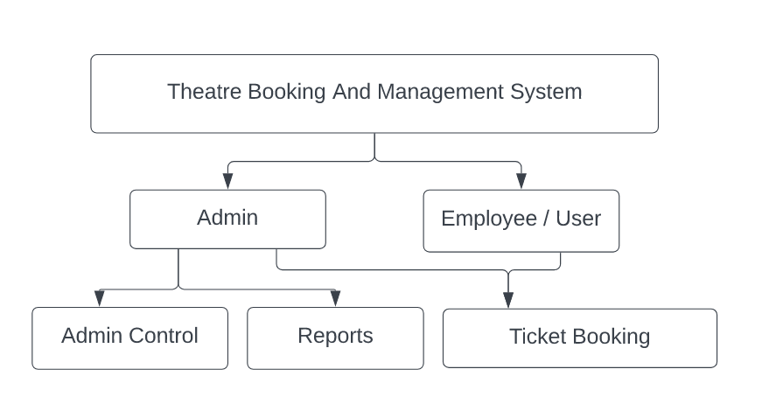

**ADMIN:**

* ADMIN MODULE:
  + - Register
    - Login
    - Insert / Update Movie List
    - Schedule Shows
    - Determine Price of Seats (Movie)
    - Manage Cash Counter
    - View Reports
* **Register:**

To be authenticated first have to be registered.

* **Login:**

The registered user can be allowed to view inner details for which he permitted.

* **Insert / Update Movie List :**

Movie Details can be updated by registered admin.

* **Show Scheduling :**

Registered admin has the power to schedule shows for a particular movie.

* **Determine Price Of Seats (Movie) :**

Registered admin can set prices of the types of seats, uniquely for each movie.

* **Manage Cash Counter :**

Registered admin can withdraw / deposit cash as per requirement from box office cash counter.

**USER:**

* EMPLOYEE / USER MODULE:
  + Register
  + Login
  + Book Tickets
  + Receive Payment and Export Ticket
  + Logout
* **Register**:

To be authenticated first have to be registered

* **Login**:

The registered user can be allowed to view inner details for which he permitted

* **Book Tickets :**

The registered user can book tickets for customer.

* **Receive Payment and Export Ticket :**

After Payment, Ticket with all necessary information is exported.

* **Logout:**

After the process of examination he turned to logout page

.

**HARDWARE & SOFTWARE SPECIFICATION FOR DEVELOPMENT**

**Hardware Requirements:**

* Intel – I5 (Processor).
* 8 GB Ram
* Hard disk 10 GB
* Display, Mouse, Keyboard

**Software Requirements:**

* **Operating System:** Windows 11
* **System Type: 64-bit**
* **Framework:** .NET Framework 4.8

**HARDWARE & SOFTWARE SPECIFICATION TO RUN APPLICATION**

**Hardware Requirements:**

* Intel - I3 (Processor).
* 2 GB Ram
* Hard disk 10 GB
* Display, Mouse, Keyboard

**Software Requirements:**

* **Operating System:** Windows 7 or Above
* **System Type: 32-bit and 64-bit**
* **Framework:** .NET Framework 4.5 or Above

**DATA FLOW DIAGRAM (DFD)**

* The data flow diagrams are pictorial or graphical representation of the outline of the system
* The data flow diagram covers all the processes and data storage area which takes place during any transaction in the system
* The data flow diagrams are functionally divided into context level, Zero level, First level, Second level, Third level and Fourth level data flow diagrams

**SYMBOLS USED FOR DFD:**

1. Data Flow: Data flow are the pipelines through the packets if information flow.
2. Process : A Process or task performed by the system
3. Entity: Entity are objects of the system. A source or destination of a system
4. Data Store : It is packet of data store

**CONTEXT LEVEL DIAGRAM**

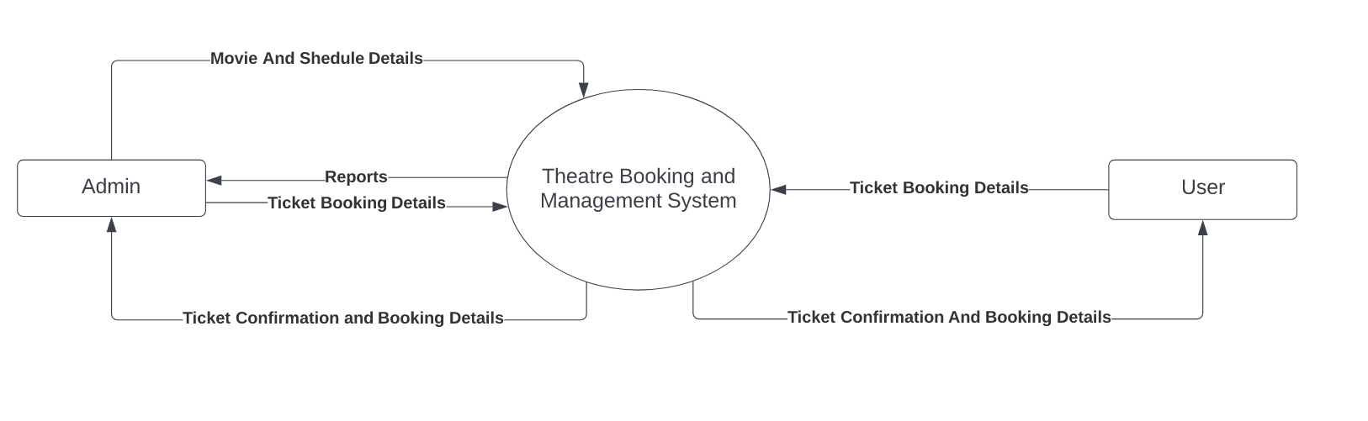

**ZERO LEVEL DIAGRAM – ADMIN**

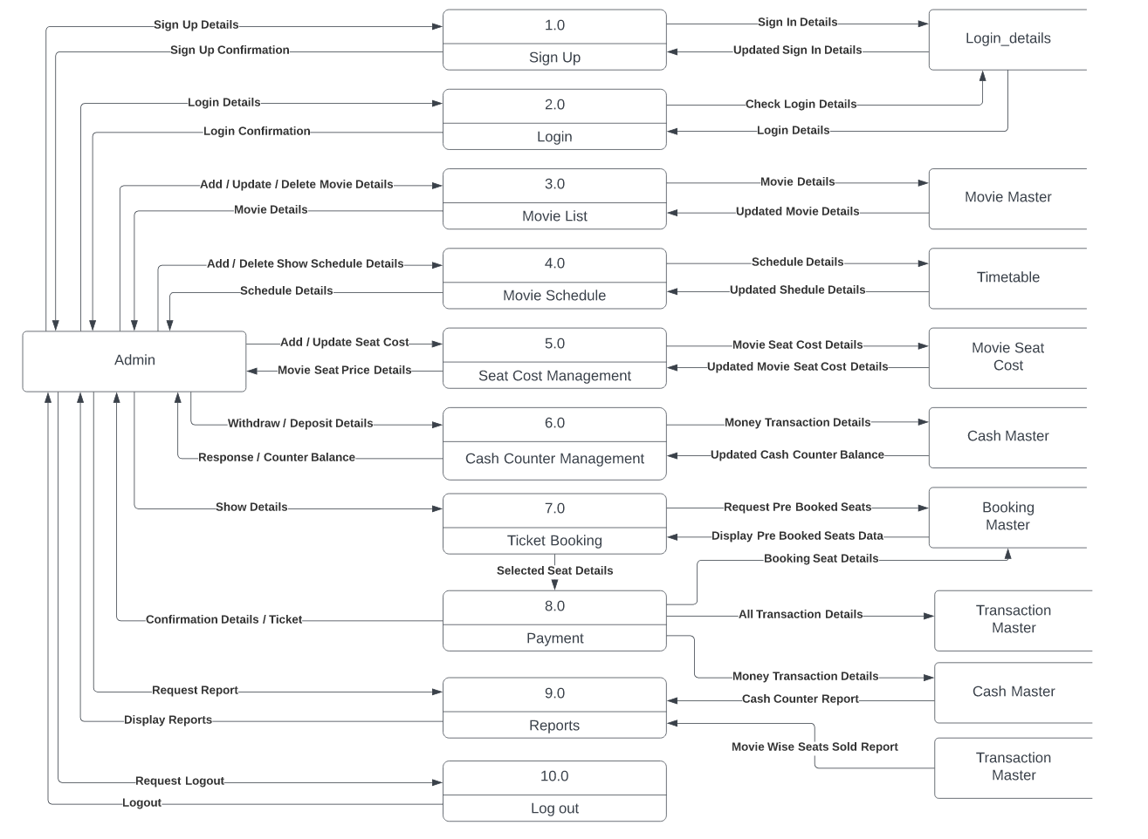

**ZERO LEVEL DIAGRAM - USER**

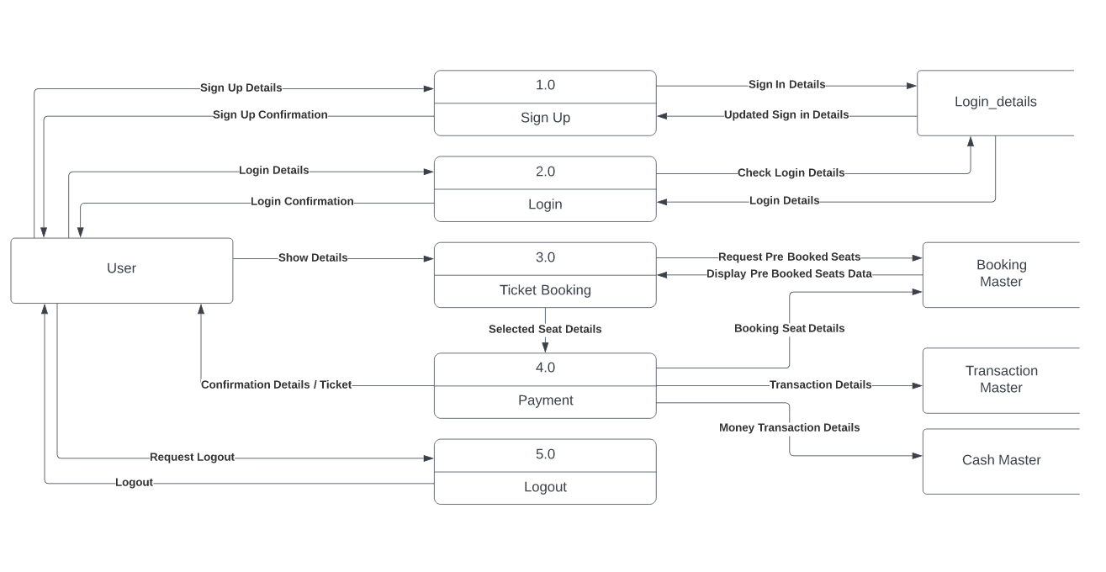

**FIRST LEVEL DIAGRAM – ADMIN**

1. **SIGNUP**

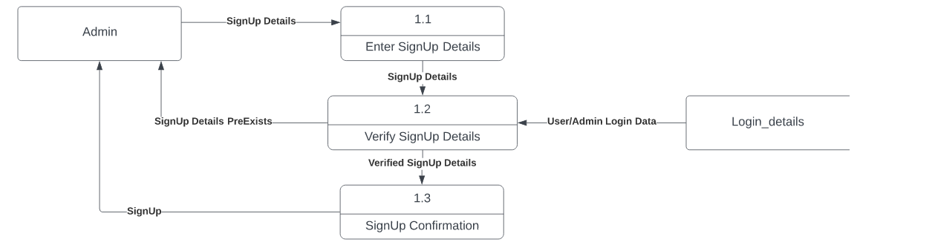

1. **LOGIN**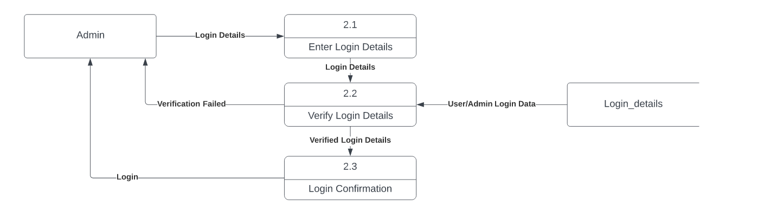
2. **MOVIE LIST**

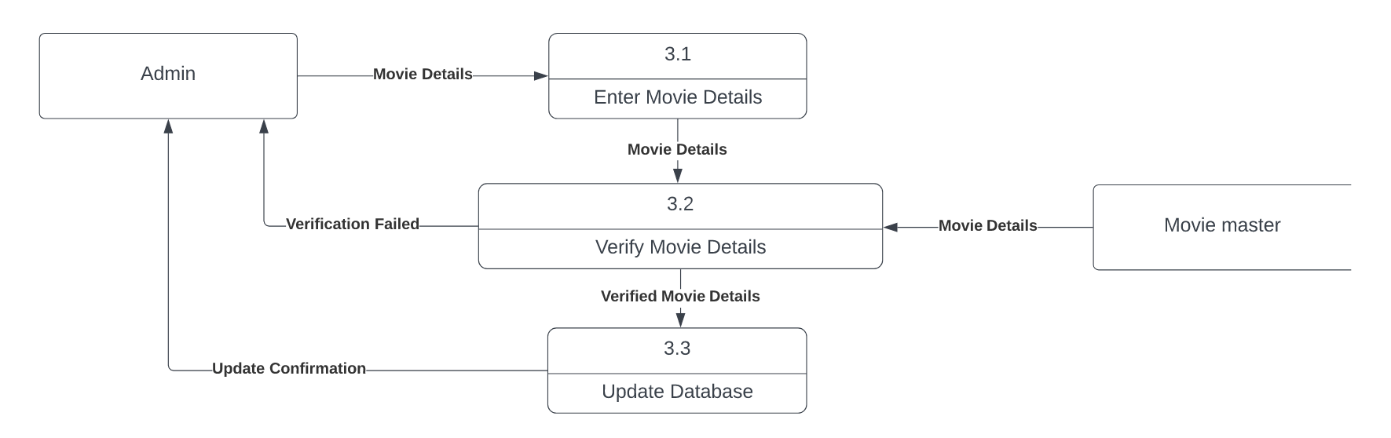

1. **MOVIE SCHEDULE**

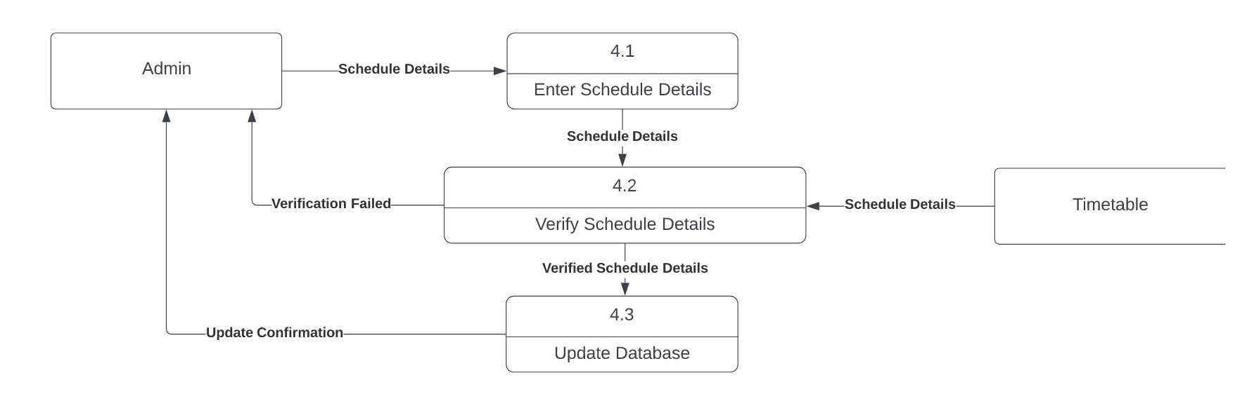

1. **MOVIE SEAT COST**

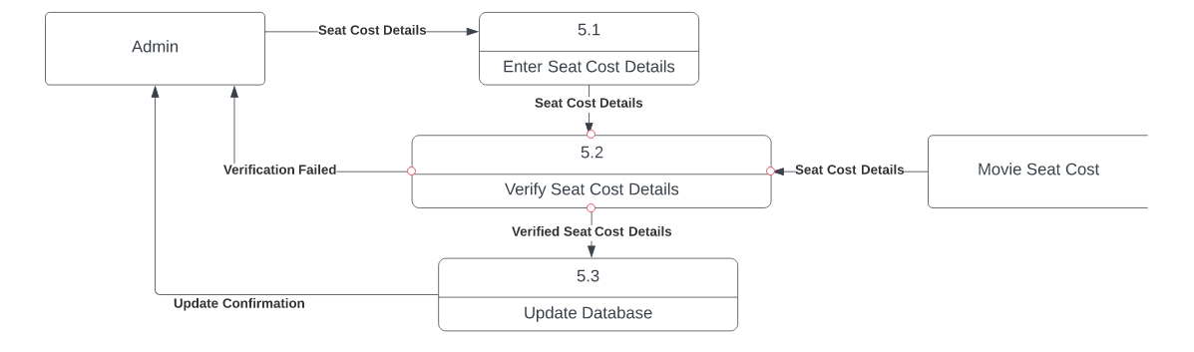

1. **CASH COUNTER MANAGEMENT**

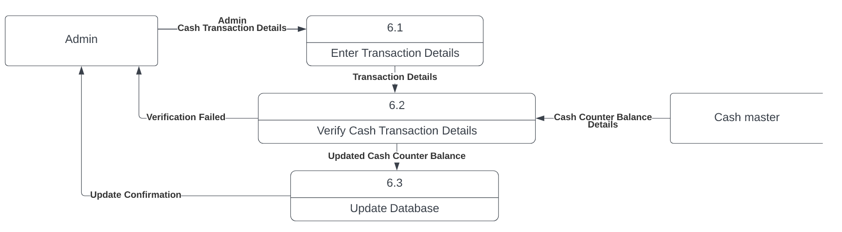

**7/8) TICKET BOOKING / PAYMENT**

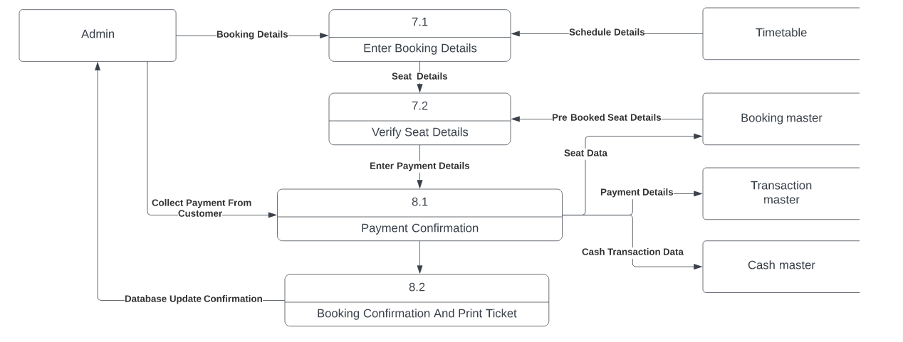

**FIRST LEVEL DIAGRAM – USER**

1. **SIGNUP**

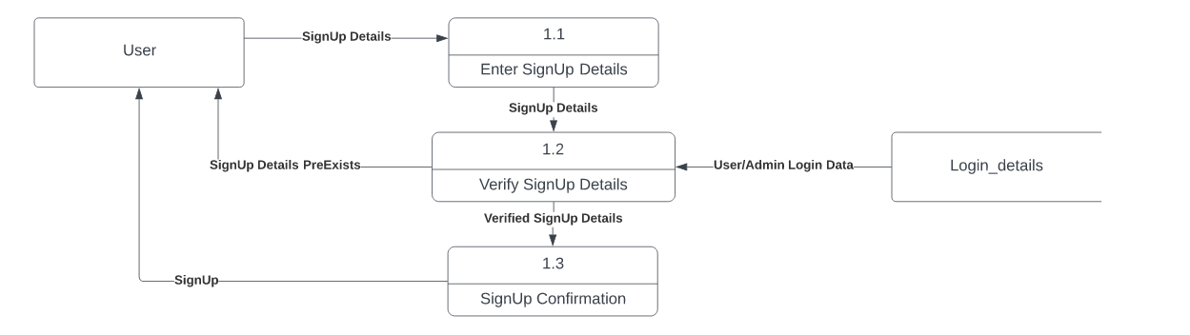

1. **LOGIN**

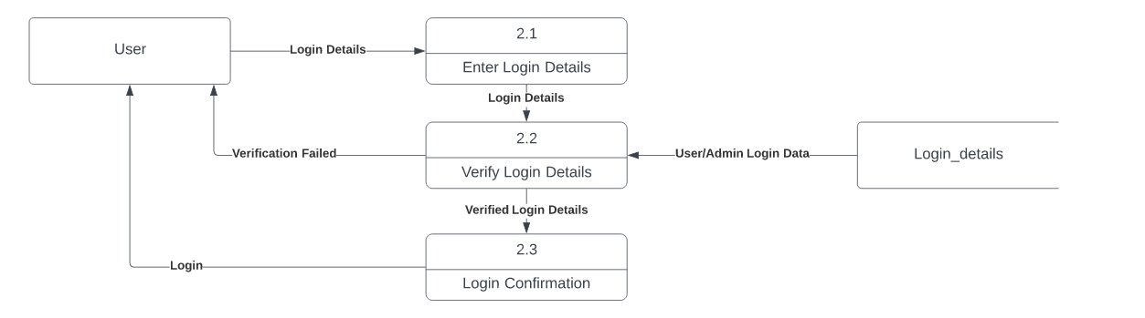

**3/4) TICKET BOOKING / PAYMENT**

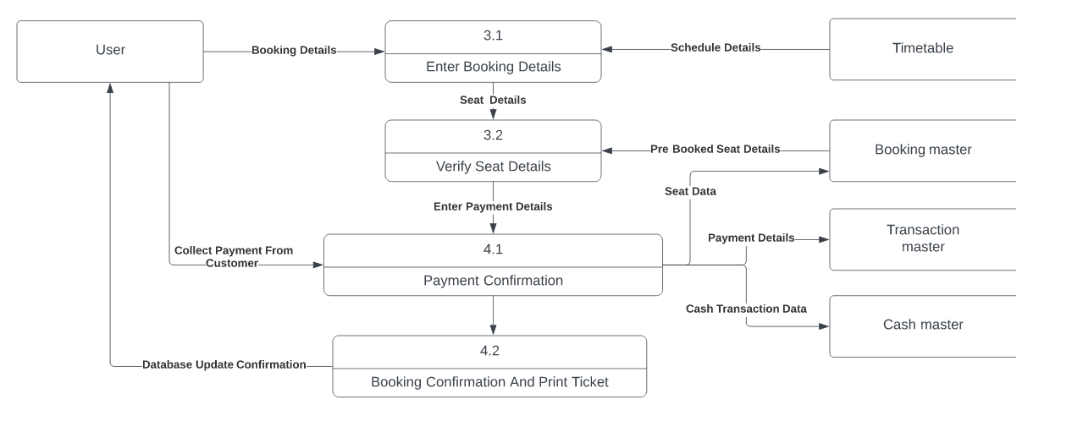

**DATABASE LAYOUT**

**DATABASE TABLES:**

1. **Login_Details (Registration) :**

|  |  |  |  |  |
| --- | --- | --- | --- | --- |
| **Column** | **Date Type** | **Size** | **Nullable** | **Primary Key** |
| **Username** | Varchar | 50 | No | Yes |
| **Password** | Varchar | 50 | No |  |
| **Admin** | Varchar | 50 | No: Default=’False’ |  |

1. **Booking_master (Ticket Booking Monitor) :**

|  |  |  |  |  |
| --- | --- | --- | --- | --- |
| **Column** | **Date Type** | **Size** | **Nullable** | **Primary Key** |
| **Bid** | Int |  | No |  |
| **Showed** | Int |  | Yes |  |
| **Seatid** | Int |  | Yes |  |

1. **Cash_master (Cash Counter Monitor) :**

|  |  |  |  |  |
| --- | --- | --- | --- | --- |
| **Column** | **Date Type** | **Size** | **Nullable** | **Primary Key** |
| **Transid** | Int |  | No | Yes |
| **Deposit** | Float |  | Yes |  |
| **Withdraw** | Float |  | Yes |  |
| **Description** | Varchar | 50 | Yes |  |
| **Date** | Date |  | Yes |  |
| **Total** | Float |  | Yes |  |

1. **Movie_master (Movie Details) :**

|  |  |  |  |  |
| --- | --- | --- | --- | --- |
| **Column** | **Date Type** | **Size** | **Nullable** | **Primary Key** |
| **Mid** | Varchar | 50 | No | Yes |
| **Mname** | Varchar | 50 | Yes |  |
| **Duration** | Numeric | 18,0 | Yes |  |
| **Cast** | Varch | Max | Yes |  |
| **Poste** | Image |  | Yes |  |
| **Status** | Varchar | 50 | Yes |  |
|  |  |  |  |  |

1. **Movie_seat_cost (Seat Price) :**

|  |  |  |  |  |
| --- | --- | --- | --- | --- |
| **Column** | **Date Type** | **Size** | **Nullable** | **Primary Key** |
| **Mid** | Varchar | 50 | No | Yes |
| **Classic** | Float |  | No |  |
| **Gold** | Float |  | No |  |
| **Premium** | Float |  | No |  |

1. **Screen_detail (Screen details) :**

|  |  |  |  |  |
| --- | --- | --- | --- | --- |
| **Column** | **Date Type** | **Size** | **Nullable** | **Primary Key** |
| **Scrid** | Int |  | No | Yes |
| **Scrname** | Varchar | 50 | No |  |

1. **Seat_details :**

|  |  |  |  |  |
| --- | --- | --- | --- | --- |
| **Column** | **Date Type** | **Size** | **Nullable** | **Primary Key** |
| **Sid** | Int |  | No | Yes |
| **Sname** | Varchar | 50 | No |  |
| **Type** | Varchar | 50 | No |  |

1. **Time_details :**

|  |  |  |  |  |
| --- | --- | --- | --- | --- |
| **Column** | **Date Type** | **Size** | **Nullable** | **Primary Key** |
| **Tid** | Int |  | No | Yes |
| **Timecode** | Int |  | No |  |
| **Time** | Varchar | 50 | No |  |

1. **Timetable (Show Schedule)**

|  |  |  |  |  |  |
| --- | --- | --- | --- | --- | --- |
| **Column** | **Date Type** | **Size** | **Nullable** | **Primary Key** | **Foreign key** |
| **Showid** | Int |  | No | Yes |  |
| **Movieid** | Varchar | 50 | Yes |  | Movie_master(mid) |
| **Screenid** | Int |  | Yes |  | Screen_detail(scrid) |
| **Date** | Date |  | No |  |  |
| **Timeid** | Int |  | Yes |  | Time_detail(tid) |

1. **Transaction_master (On Ticket Booking)**

|  |  |  |  |  |
| --- | --- | --- | --- | --- |
| **Column** | **Date Type** | **Size** | **Nullable** | **Primary Key** |
| **Transid** | Int |  | No | Yes |
| **Phone** | Varchar | 50 | No |  |
| **Movietitle** | Varchar | 50 | Yes |  |
| **Date** | Varcha | 50 | Yes |  |
| **Time** | Varchar | 50 | Yes |  |
| **Seats** | Varchar | 50 | Yes |  |
| **Classic** | Int |  | Yes: Default = 0 |  |
| **Gold** | Int |  | Yes: Default = 0 |  |
| **Premium** | Int |  | Yes: Default = 0 |  |
| **Totalcost** | Float |  | Yes |  |

**DESIGN OF INPUT / OUTPUT SCREEN**

**SIGNUP / LOGIN WINDOW**

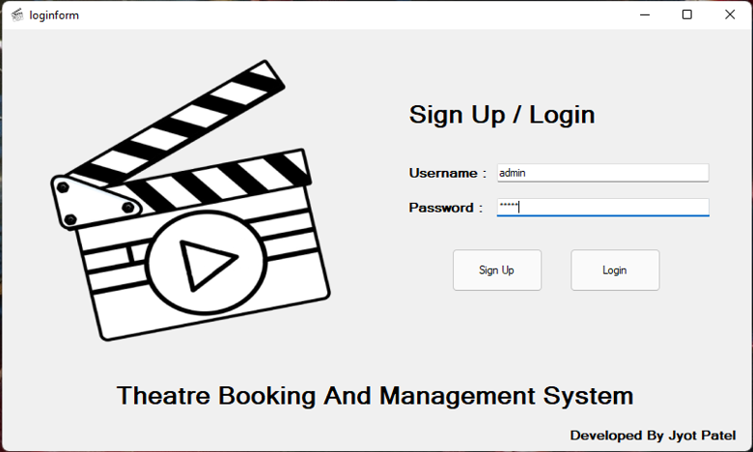

**When Clicked SignUp…**

**( Yes -> Admin , No -> Employee/User )**

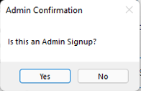

**MOVIE SELECTION WINDOW**

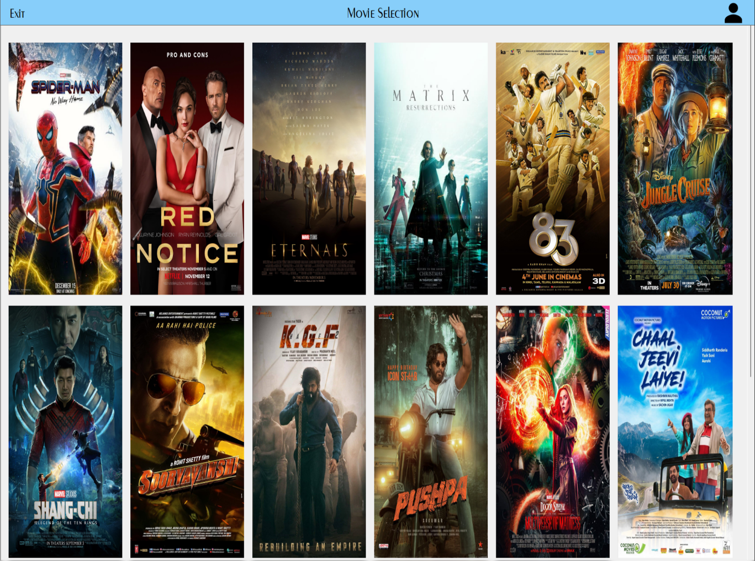

* Movie posters are click-able to navigate to Show Selection and Seat

Selection Window

* Administrator login has an Admin logo on Top-Right to navigate to

Admin Interface Window.

* Employee / User login only has option to log-off.

**SHOW AND SEAT SELECTION WINDOW**

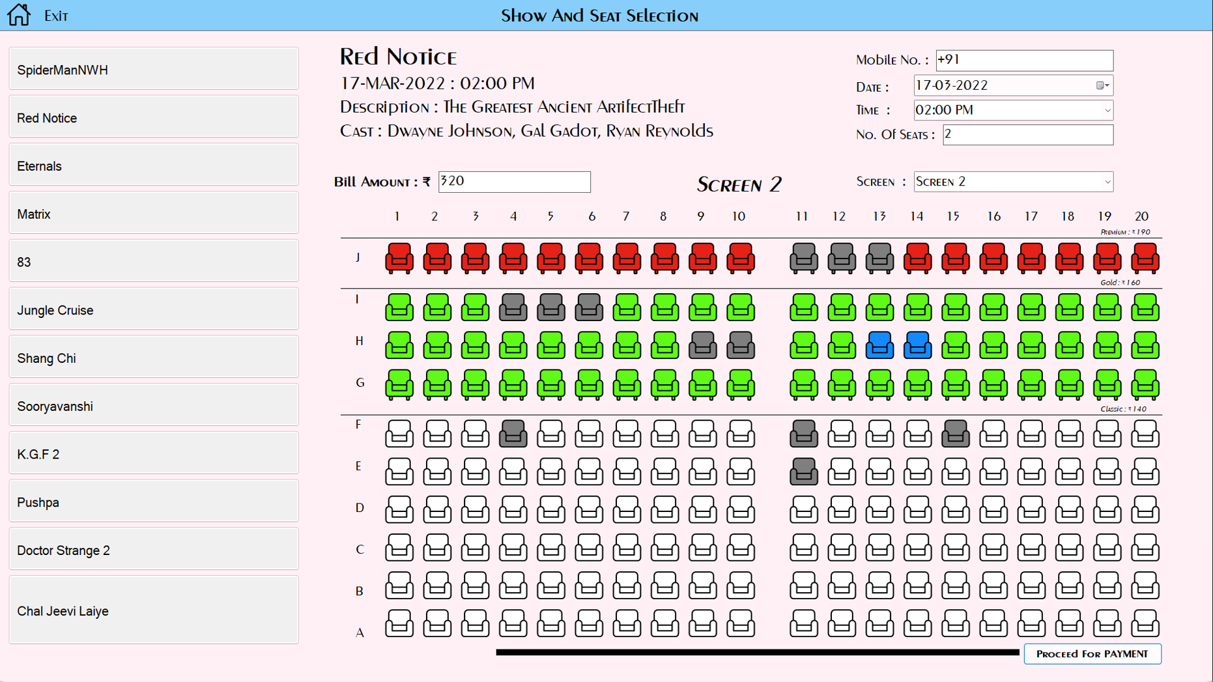

* Movies Can Be Selected From Left Panel.
* Customers Mobile Number is required for reference (optional).
* Details for the Show for the Movie are to be selected.
* Total Bill Amount and Total Seats Selected is displayed.

**PAYMENT WINDOW**

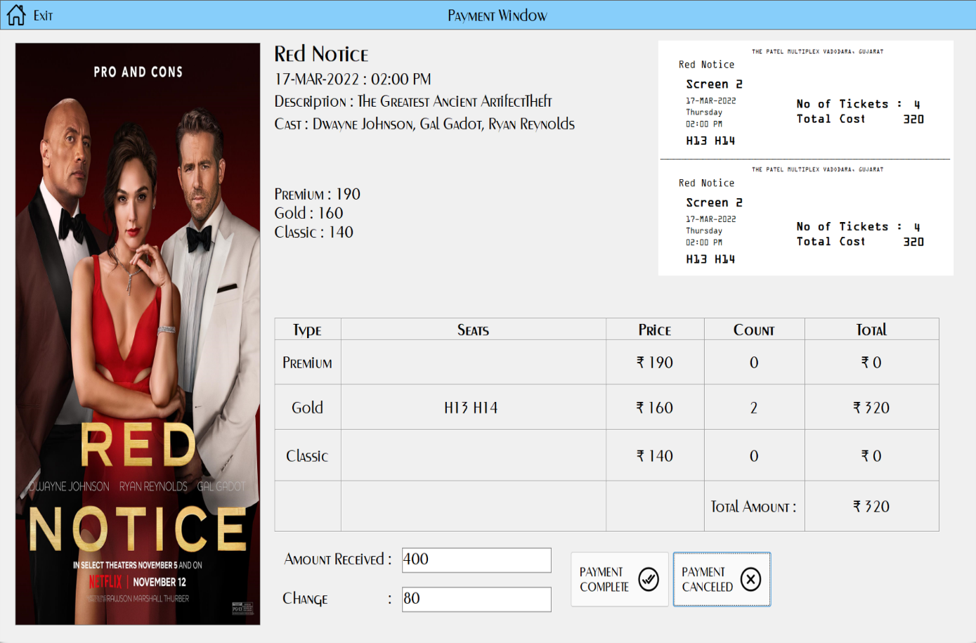

* Amount Received from customer is entered.
* Change is automatically calculated.
* If the payment is complete, the displayed ticket is printed.
* If payment is canceled, the ticket is not printed.
* And then, application is redirected to Movie Selection Window.

**ADMIN INTERFACE WINDOW**

TAB – MOVIE LIST

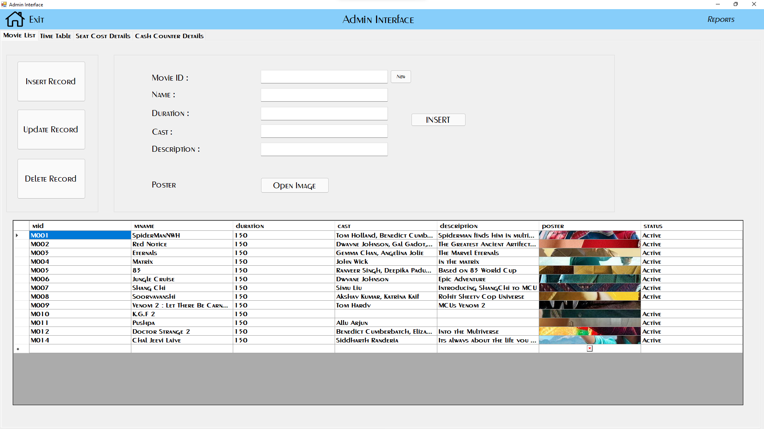

* Movie List Tab provides the administrator complete control on

Movie List Database

* Administrator can Insert, Update, Delete information about

a new / existing movie in the database.

* Administrator can select which movies to be displayed in application

using the “status” property for a movie.

**ADMIN INTERFACE WINDOW**

TAB – TIMETABLE

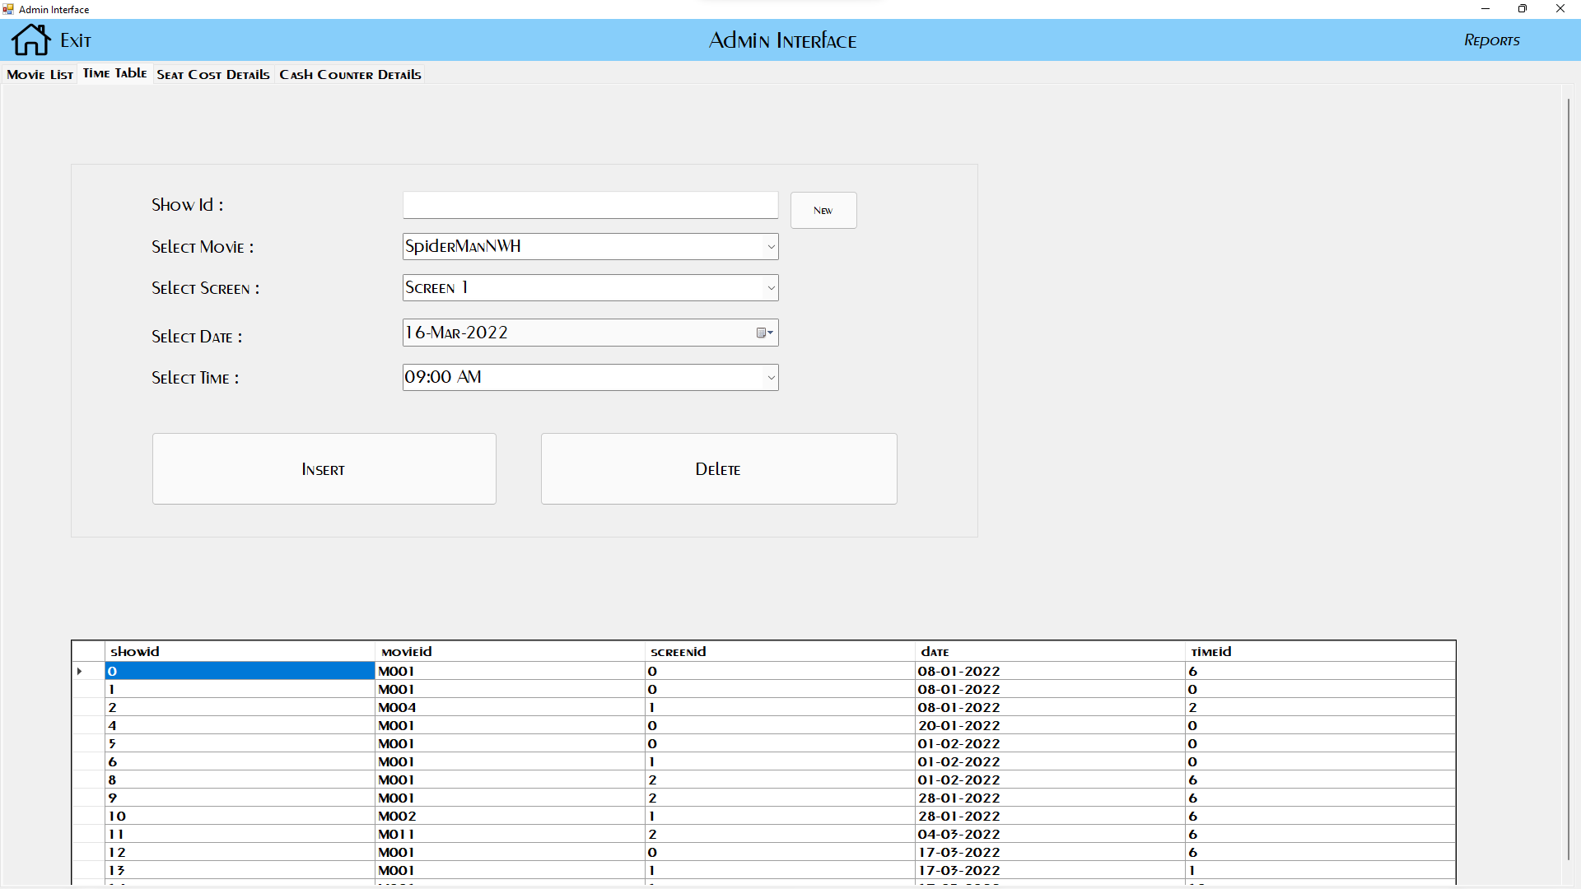

* Time Table Tab provides the administrator complete control on

Time Table Database to schedule show timings

* Administrator can Insert, Delete Show timing information about

an existing movie in the database.

**ADMIN INTERFACE WINDOW**

TAB – SEAT COST DETAILS

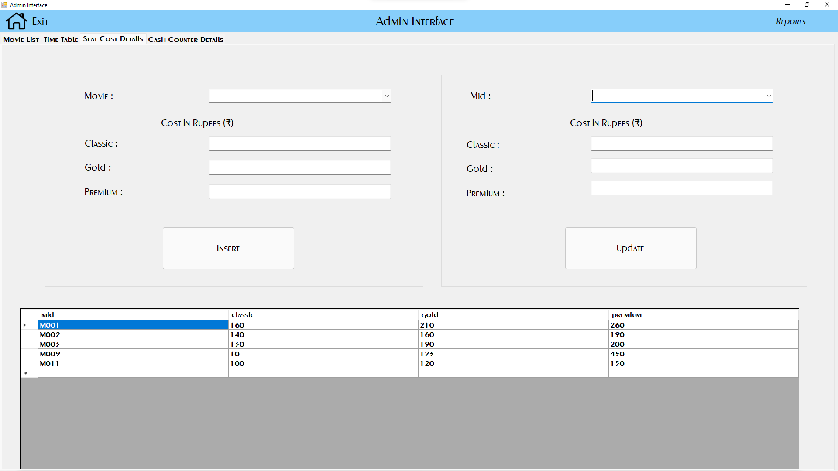

* Seat Cost Details Tab provides the administrator complete control on

Seat Price Database.

* Administrator can Insert, Update seat prices for an existing movie

in the database.

**ADMIN INTERFACE WINDOW**

TAB – CASH COUNTER DETAILS

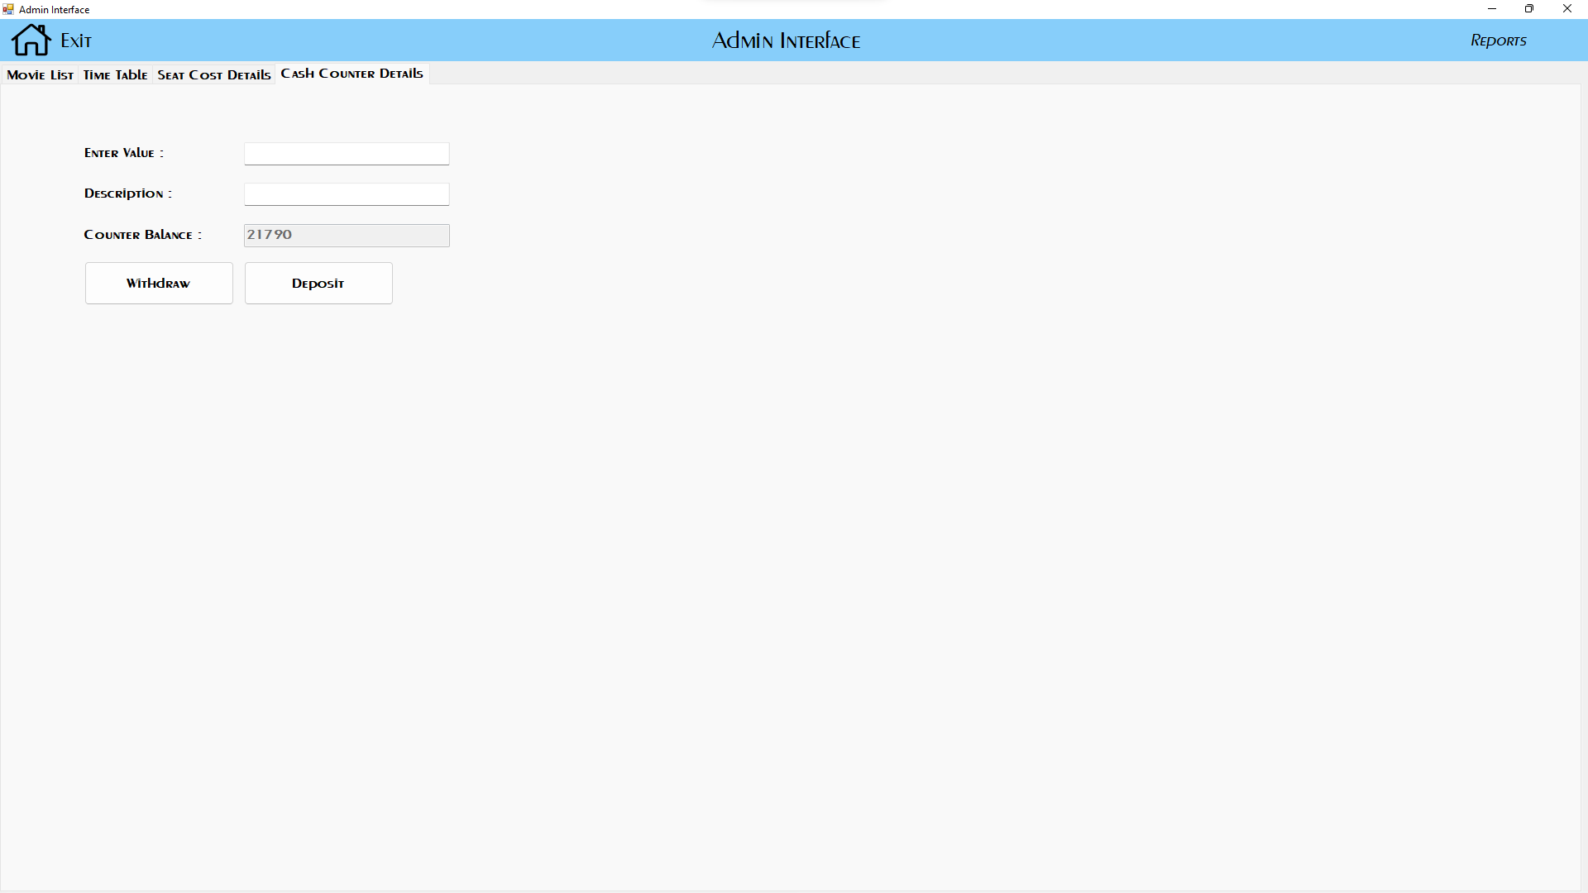

* Cash Counter Details Tab provides the administrator control on

Cash Counter Database.

* Administrator can Withdraw or Deposit Money from the BoxOffice

Cash Counter. And that transaction can be recorded using this tab.

**REPORTS**

**Cash Transaction Report from Cash Counter Report**

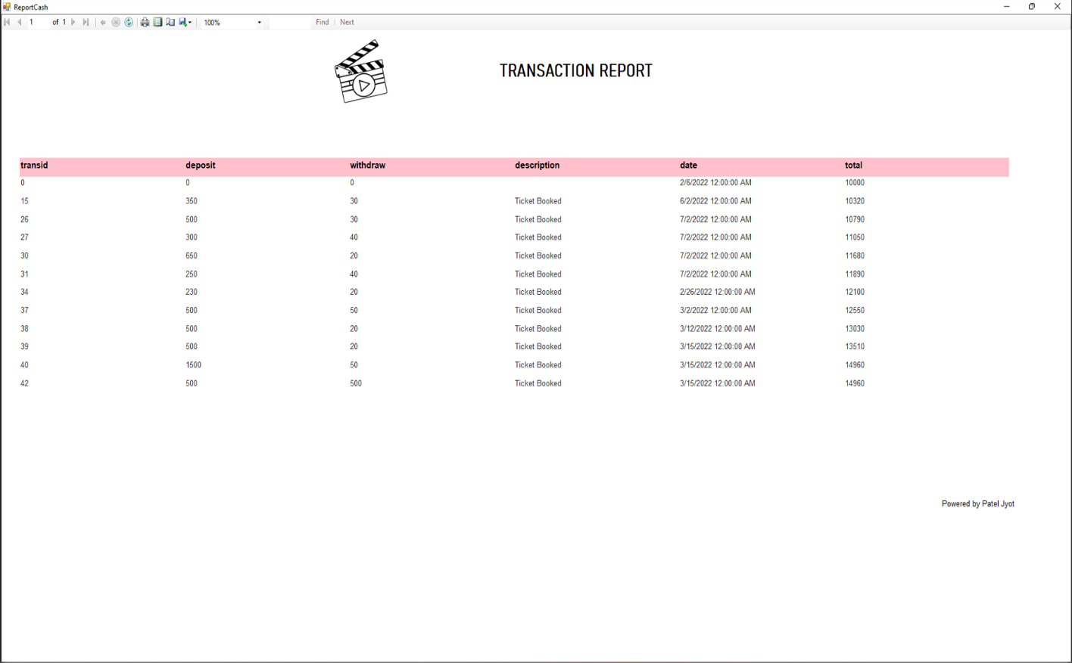

**Movie-wise Ticket Sold and Gross Collection Report**

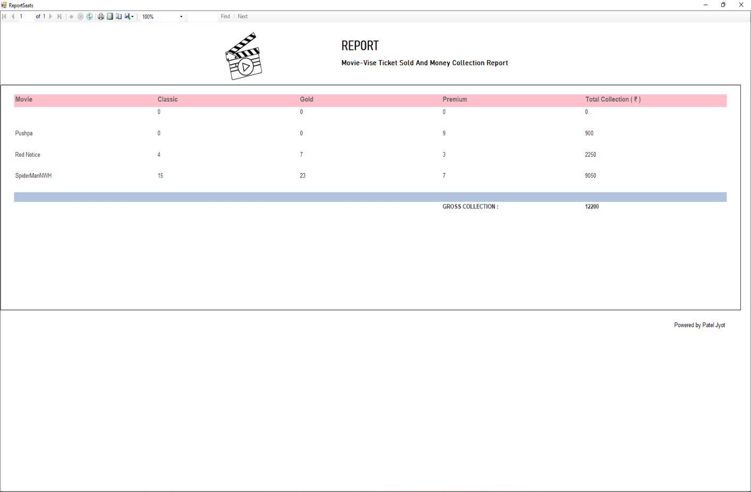

**LIMITATIONS**

* A Movie Schedule should be displayed, for the ease of selection for the customer.
* Easier way of show selection should be introduced to the system.
* Application runs on a single computer.
* Tickets can only be booked offline.

**CONCLUSION**

The package was designed in such a way that future modifications can be done easily. The following conclusions can be deduced from the development of the project.

* + Automation of the entire system improves the efficiency
  + It provides a friendly graphical user interface which proves to be better when compared to the existing system.
  + It gives appropriate access to the authorized users depending on their permissions.
  + It effectively overcomes the delay in communications.
  + Updating of information becomes so easier.
  + System security, data security and reliability are the striking features.
  + The System has adequate scope for modification in future if it is necessary.

**BIBLIOGRAPHY**

The following books were referred during the analysis and execution phase of the project.

**Books Referred:**

* Visual Basic 6 Programming Black Book ( Steven Holzer )
* Visual Basic

**Websites Referred:**

* Lucid.app
* Youtube.com
* draw.io
* stackoverflow.com